# Chapter 1: INTRODUCTION

## About Company:

#### **Augmentix Pvt. Ltd.**

Founded in 2020, Augmentix is a software solutions company that assists companies worldwide in improving design, manufacturing, and service processes for a smart, connected world. We provide innovative services across various domains, including Mechanical CAD (MCAD), Product Lifecycle Management (PLM), Application Lifecycle Management (ALM), Internet of Things (IoT), Augmented Reality (AR), Digital Twin, and Industry 4.0. Our offerings help customers unlock the value of digitization, extract more value from third-party applications, and optimize business functions such as engineering, software development, supply chain management, manufacturing, and service. By coordinating these processes, we enable product and service advantages for our clients in discrete manufacturing organizations.

**Address:** J-602, Astonia Royale, Near Sinhgad Road Mumbai-Bangalore Highway, Pune, Maharashtra, 410046

### **Organizational Structure**

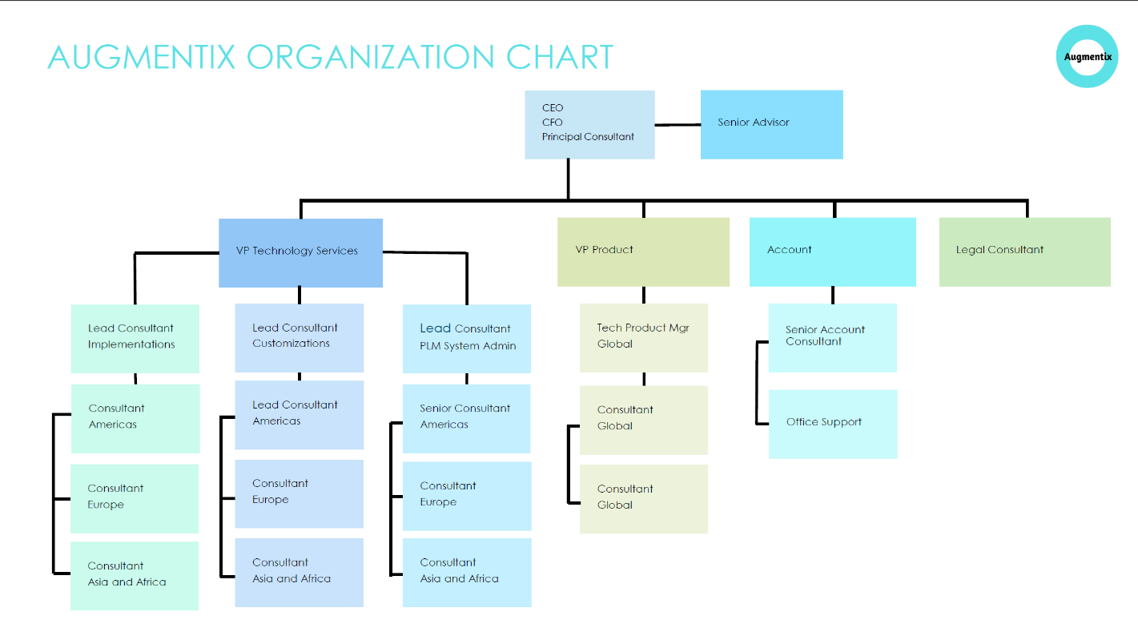

## 2. Services

### **Introduction to Services**

Specialties: Business Consulting, Training Program, Software Solution, Process Consultant, Windchill Customization, Functional Consultant, System Administration, Business Administration, Test Engineer, CAD customization, CAD Designers, Product Developers, Migration, PLM implementation, Value Road Map.

### **Services offered by the company**

#### **Public relation firm**

* + 1. Business Consulting
    2. Training Program
    3. Software Solution
    4. Process Consultant
    5. Windchill Customization
    6. Functional Consultant
    7. System Administration
    8. Business Administration
    9. Test Engineer
    10. CAD customization
    11. CAD Designers
    12. Product Developers
    13. Migration
    14. PLM implementation
    15. Value Road Map
  1. **Number of employees: 16**

2

## 3.Web development

### **Introduction to Web development:**

Web development is the process of creating websites and web applications. It encompasses several different tasks, including web design, web content development, client-side/server-side scripting, and network security configuration, among others. Web development can be divided into two main categories: front-end development and back-end development.

1. **Front-end development:**

* Html (Hyper Text Markup Language)
* CSS (Cascading style sheets)
* JavaScript

1. **Back-end development:**

* Server side languages
* Databases
* Web servers

1. **Full-stack development**
2. **Web development tools and platforms:**

* Text editors and IDEs
* Version control systems
* Build tools and task runners
* Testing frameworks
* Content management systems
* Hosting and deployment services

Web development is a vast field with many specializations, and it's a critical component of the digital economy, enabling businesses and individuals to establish an online presence and deliver services over the internet.

3

.

### **Need of web development:**

* Online presence
* Information dissemination
* E-commerce
* Communication and collaboration
* Accessibility
  1. **Significance of web development:**
* User experience
* Brand identity
* Search engine optimization (SEO)
* Security
* Social performance
  1. **Use of web development:**
* Business and e-commerce
* Content management
* Social media and networking
* Education and e-learning
* Entertainment and media
* Government and public services
* Healthcare and telemedicine

## 4. Front-end development

### **Introduction:**

Front-end development, also known as client-side development, is the practice of producing HTML, CSS and JavaScript for a website or web application so that a user can see and interact with them directly the challenge associated with front-end development is the development of the websites or application visual layout and ensuring that it is user- friendly and responsive.

### **Technologies involved in Front-end development:**

1. **Core technologies:**

* HTML (Hypertext markup language)
* CSS (cascading style sheets)
* JavaScript

1. **Frameworks and libraries:**

* React
* Angular
* ZVue.js

1. **Tools and technologies:**

* Package managers
* Build tools
* version control
* Testing
* CSS preprocessors
* Responsive design
  1. **Use for front-end development**

* User interface (ui) creation
* User experience(ux) enhancement
* Interactivity and dynamic content
* Accessibility
* Performance optimization
  1. **Need for front-end development**
* Digital presence
* User engagement
* Mobile compatibility
* Competitive advantage
* SEO benefit

## 5.Individual project

For individual project we were told to make a simple website using HTML, CSS and JavaScript. I made a To-Do website (app) which is a called as todo a basic To-Do list where you can have your record of the day or the events you want to do.

This project includes:

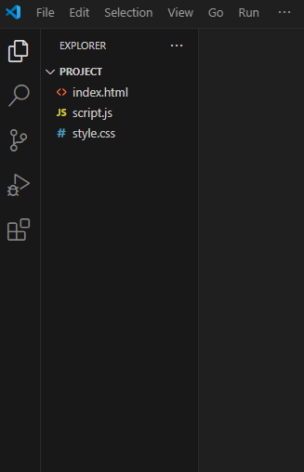**HTML Files**: index.html

**CSS Files**: style.css

**JavaScript Files**: script.js

These files collectively define the structure, style, and functionality of the project, along with enhancing user experience through multimedia elements.

**1.The website Page**

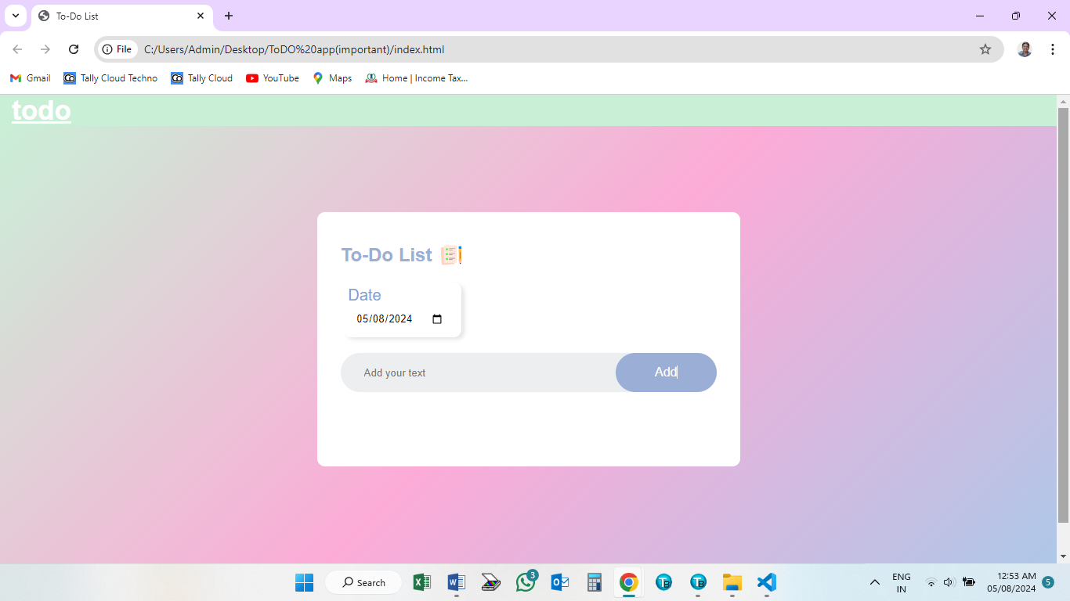

16

**2.Select your Date**

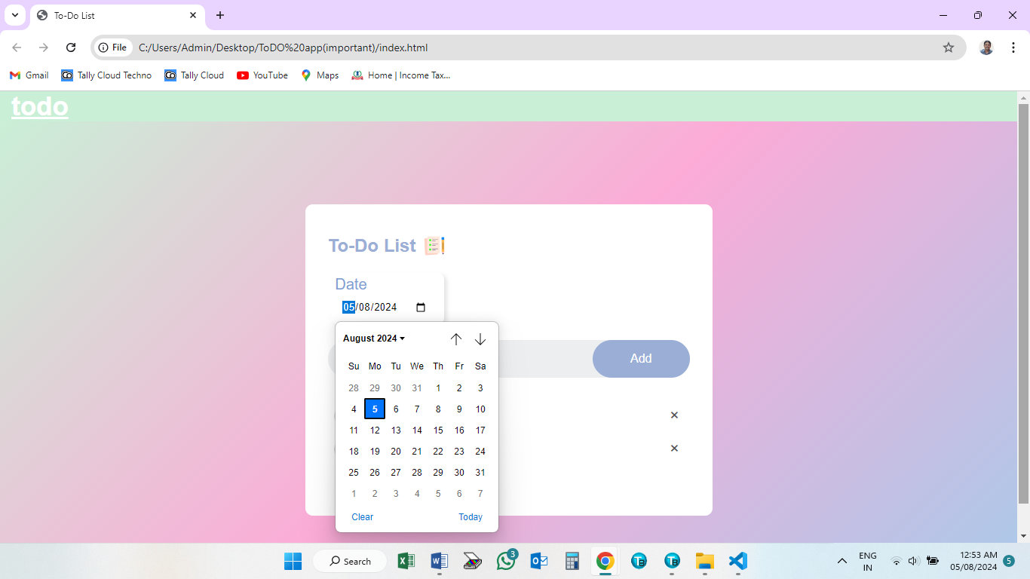

**3.Creating the To-Do list**

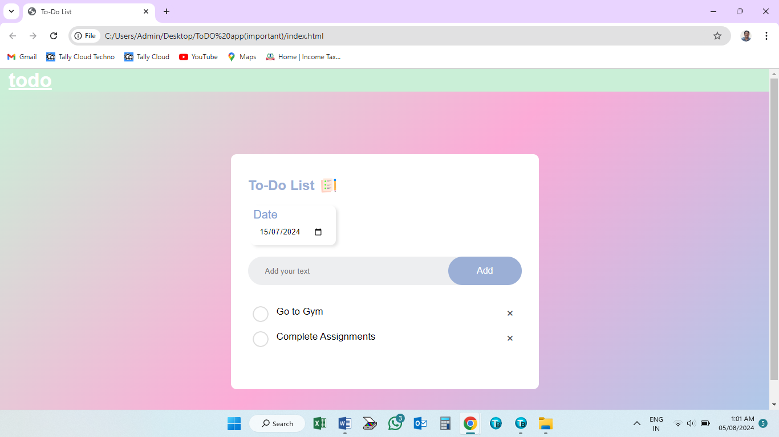

**4.Completed task**

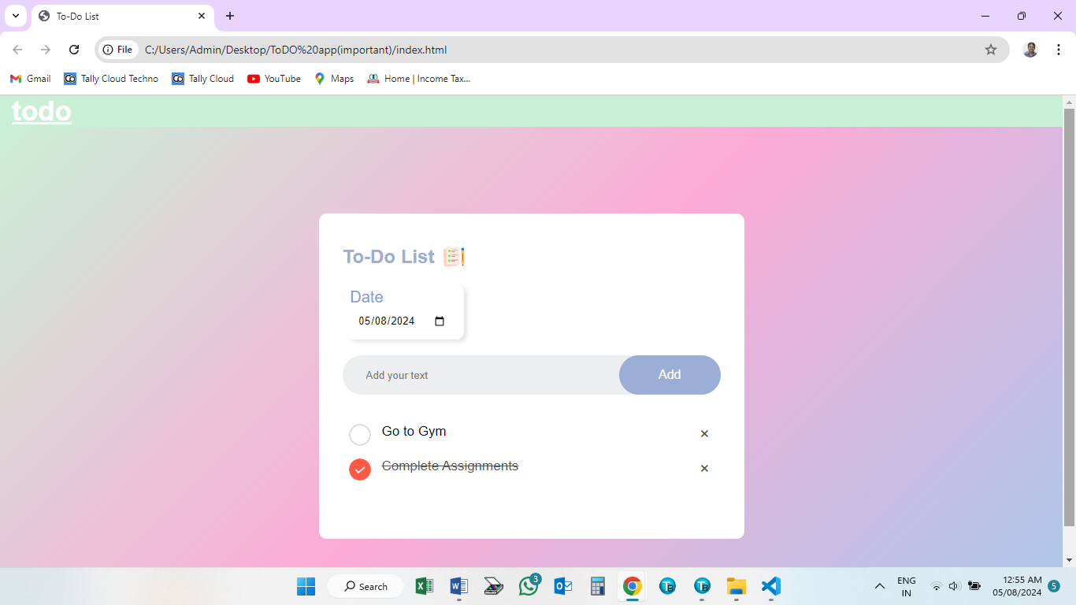

## 6. Group Project

### **6.1 Introduction:**

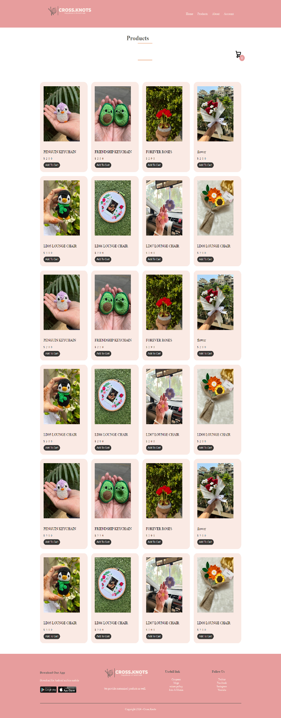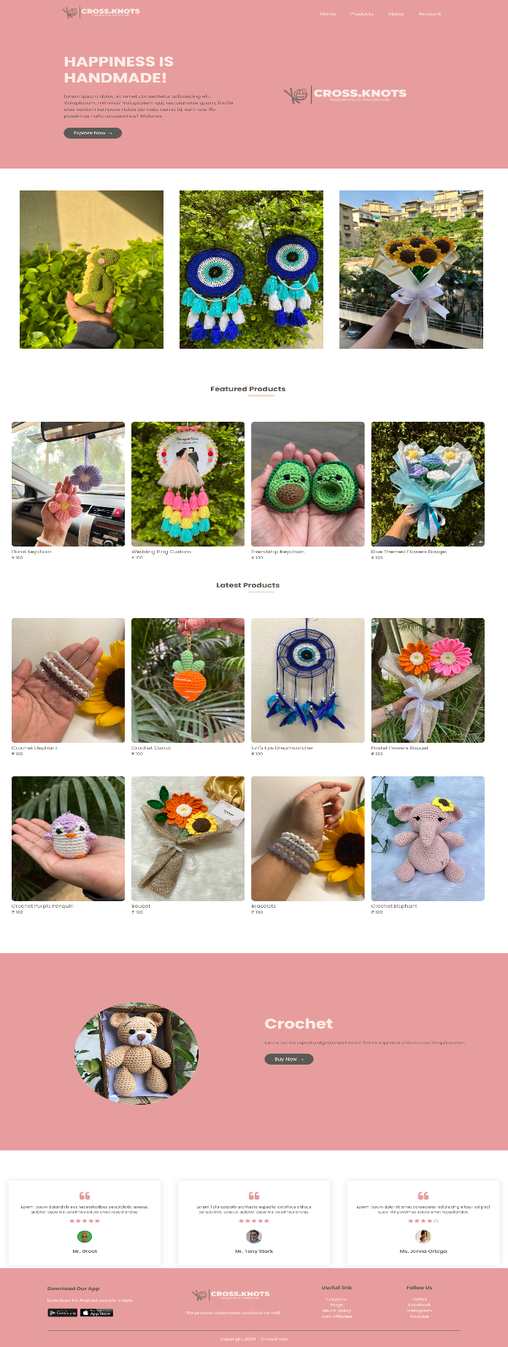Creating an E-Commerce website for a small Cr

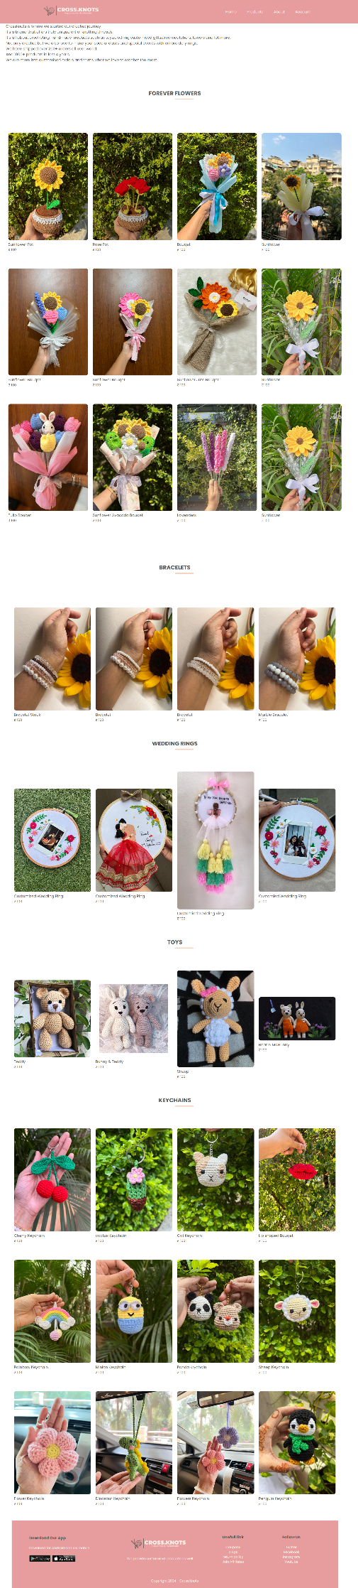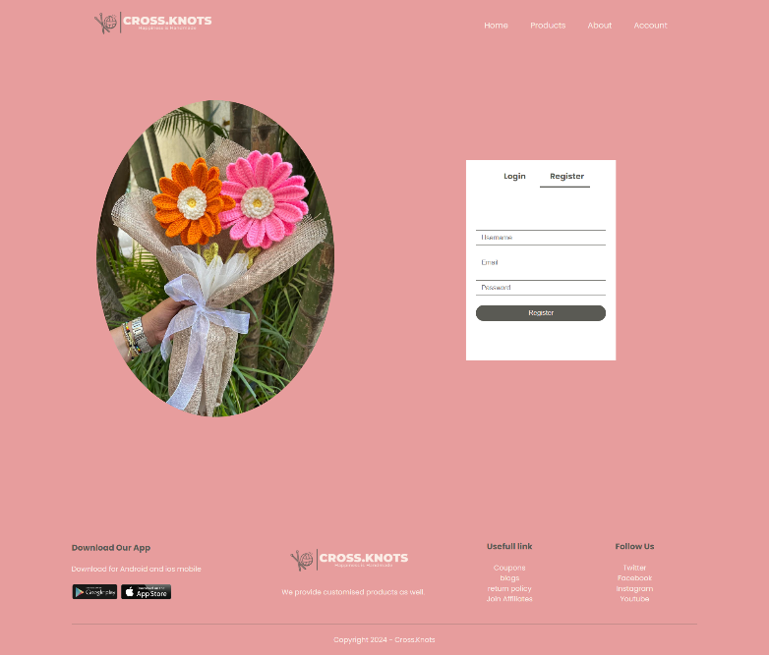

**7. Software Development Lifecycle**

### **7.0 Introduction:**

The Software Development Life Cycle (SDLC) is a framework that defines the stages involved in the development of software. It is a structured process that helps in the construction of high-quality software. The SDLC hierarchy is not typically represented as a hierarchy in the sense of a tree structure, but rather as a sequence of phases or stages that a project goes through from conception to maintenance

### **7.1 Hierarchy:**

* **Release theme**

A "release theme" in the context of software development typically refers to a central concept or focus that defines a particular version or iteration of a software product. The theme helps to guide the development team in making decisions about which features to prioritize and how to align the work with the overall goals of the project or product. Release themes are often used in Agile development methodologies, such as Scrum, where each sprint or release cycle is intended to deliver a potentially shippable increment of product.

* **Epic**

In the context of software development, particularly within Agile methodologies like Scrum, an "Epic" is a large user story, which is too big to fit into a single sprint or iteration. Epics are used to capture large, coarse-grained requirements or ideas that can later be broken down into smaller, more manageable pieces called "user stories" or "features."

An Epic typically represents a significant amount of work and can often be complex, involving multiple systems or components. It is a placeholder for a group of related user stories that share a common theme and can be prioritized as a single unit within the product backlog.

* **Stories**

In the context of software development, particularly within Agile methodologies, "stories" typically refer to "user stories." User stories are a simple way to articulate a requirement or a feature from the perspective of the end user or customer. They are used to ensure that the development team focuses on delivering value to the user with each piece of functionality they create.

* **Stabilization**

Stabilization in the context of software development refers to the process of making a software product more stable, reliable, and bug-free. This typically occurs after the initial development phase and before the final release of the software. The goal of stabilization is to ensure that the software performs well under expected conditions and that it meets the quality standards set by the development team or the organization.

### **7.2 Windchill:**

Windchill is a Product Lifecycle Management (PLM) application developed by PTC (Parametric Technology Corporation). It is designed to help companies manage their product-related information and processes throughout the entire lifecycle of a product, from its conception, through design and manufacturing, to service and disposal.

Windchill is used by a variety of industries, including aerospace, automotive, industrial machinery, medical devices, and consumer goods, to streamline product development processes and improve product quality and time-to-market. It is part of PTC's broader suite of software solutions that also include CAD, augmented reality (AR), and service lifecycle management (SLM) tools.

**Steps to open windchill:**

1. Open all the servers required

* Web server
* Database server
* Directory server
* Application server

1. Windchill Shell
2. Command prompt
3. Windchill start

12

**8. Conclusion**

### We learned how to effectively use HTML, CSS, and JavaScript to build and style web pages, creating responsive and visually appealing designs. Our experience with modern frameworks and libraries like React, Angular, and Vue.js enhanced our ability to develop interactive and dynamic user interfaces. Additionally, by working on projects such as the blogging website "heart.out" and an E-Commerce platform for a small crochet business, we honed our skills in both individual and collaborative settings. We also gained a deep understanding of the Software Development Lifecycle (SDLC), learning how to navigate through phases from conception to stabilization, ensuring the delivery of high-quality software solutions. This comprehensive learning journey has equipped us with the knowledge and expertise to tackle real-world web development challenges and contribute effectively to the digital transformation of businesses

13

# 9. EXPERIENCE ENCOUNTERED

## Experience Encountered :

Our 6-week training of Implant training on Software/Web Development was a fun, interesting, and learning experience where I learned something new and out of my field which was very nice to me, and also it gave me new marketing knowledge.

We have enjoyed a lot the internship we are having, because it is the way we have been taught yet, instead of just having a theory we were also have been given practical tasks, which are very much easy and tend to do. Our faculty teaches us in such a way that we are interestingly looking for future stuff. Also, our faculty taught not only theoretical knowledge but also gives practical knowledge with real-world examples like I still remember at the beginning he made us understood the concept of software development, html, css, etc. with real-world based examples.

This Implant training gave us knowledge about a new and very interesting field of marketing, also it taught us to build up brand and ways of marketing using creatives ways.

**References:**

* <https://scaledagileframework.com/>
* <https://www.w3schools.com/html/>
* <https://html.com/>
* <https://en.wikipedia.org/wiki/CSS>
* <https://developer.mozilla.org/en-US/docs/Web/CSS>

14

14